**Балтийский государственный технический университет**

**«ВОЕНМЕХ» им. Д.Ф. Устинова**

**Кафедра И9**

**«Информационные системы и компьютерные технологии»**

**Лабораторная № 4**

**Вариант 7**

**По дисциплине: «МАТ.СТАТИСТИКА И СП** **»**

**Выполнил:**

Студент Кузнецов С.Н.

Группа И322

**Преподаватель:**

Брацлавский А.А.

Санкт-Петербург

2015

**Исходные значения:**

Месяц рождения – 10

Номер по списку - 7

mx=10

my=1.5

Dx=7

Dy=10

σx=2.645

σy=3.162

1. Проверка гипотезы о числовом значении математического ожидания нормального распределения при известной дисперсии

**Hypothesis Tests for RAND3**

Sample mean = 10,0993

Sample median = 10,3024

Sample standard deviation = 2,43252

t-test

Null hypothesis: mean = 10,0

Alternative: not equal

Computed t statistic = 0,288788

P-Value = 0,773962

Do not reject the null hypothesis for alpha = 0,1.

sign test

Null hypothesis: median = 10,0

Alternative: not equal

Number of values below hypothesized median: 22

Number of values above hypothesized median: 28

Large sample test statistic = 0,707107 (continuity correction applied)

P-Value = 0,479498

Do not reject the null hypothesis for alpha = 0,1.

signed rank test

Null hypothesis: median = 10,0

Alternative: not equal

Average rank of values below hypothesized median: 27,2273

Average rank of values above hypothesized median: 24,1429

Large sample test statistic = 0,366825 (continuity correction applied)

P-Value = 0,713746

Do not reject the null hypothesis for alpha = 0,1.

chi-square test

Null hypothesis: sigma = 2,645

Alternative: not equal

Computed chi-square statistic = 41,4435

P-Value = 0,460386

Do not reject the null hypothesis for alpha = 0,1.

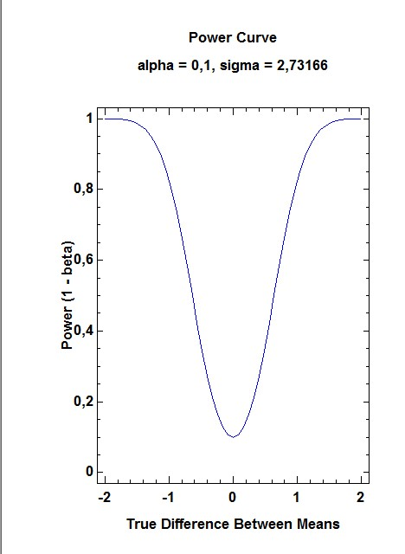

**Hypothesis Tests**

Sample means = 10,0993 and 11,5146

Sample standard deviations = 2,43252 and 3,00113

Sample sizes = 50 and 100

90,0% confidence interval for difference between means: -1,4153 +/- 0,81007 [-2,22537;-0,60523]

Null Hypothesis: difference between means = 0,0

Alternative: not equal

Computed t statistic = -2,89189

P-Value = 0,00440714

Reject the null hypothesis for alpha = 0,1.

(Equal variances assumed).

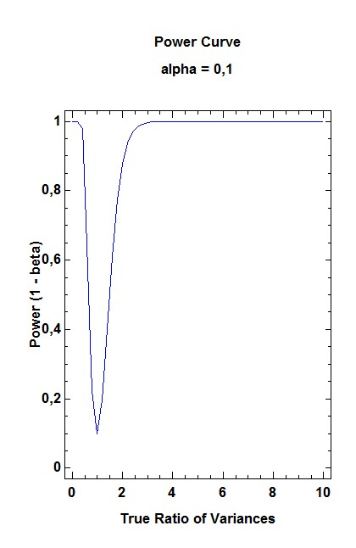**Hypothesis Tests**

Sample standard deviations = 2,43252 and 3,00113

Sample sizes = 50 and 100

90,0% confidence interval for ratio of variances: [0,443395;1,00581]

Null Hypothesis: ratio of variances = 1,0

Alternative: not equal

Computed F statistic = 0,656966

P-Value = 0,104645

Do not reject the null hypothesis for alpha = 0,1.